DEPARTMENT OF BOTANY



FIELD TRIP
ACADEMIC YEAR- (2025-26)

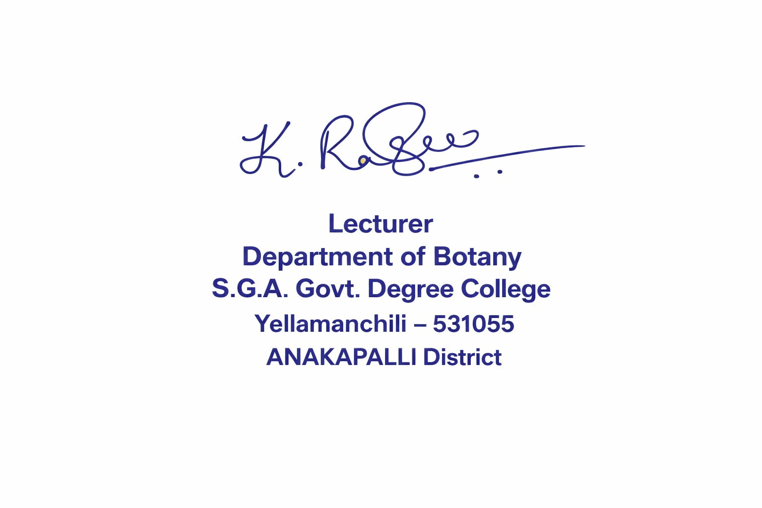


SIGNATURE OF LECTURER SIGNATURE OF PRINCIPAL


DEPARTMENT OF BOTANY
BOTANICAL FIELD TRIP FOR 2nd BSc BOTANY (09-12-2025)
PLACE: LINE KOTTHURU VILLAGE
TOPIC: SOME VILLAGE MEDICINAL PLANTS
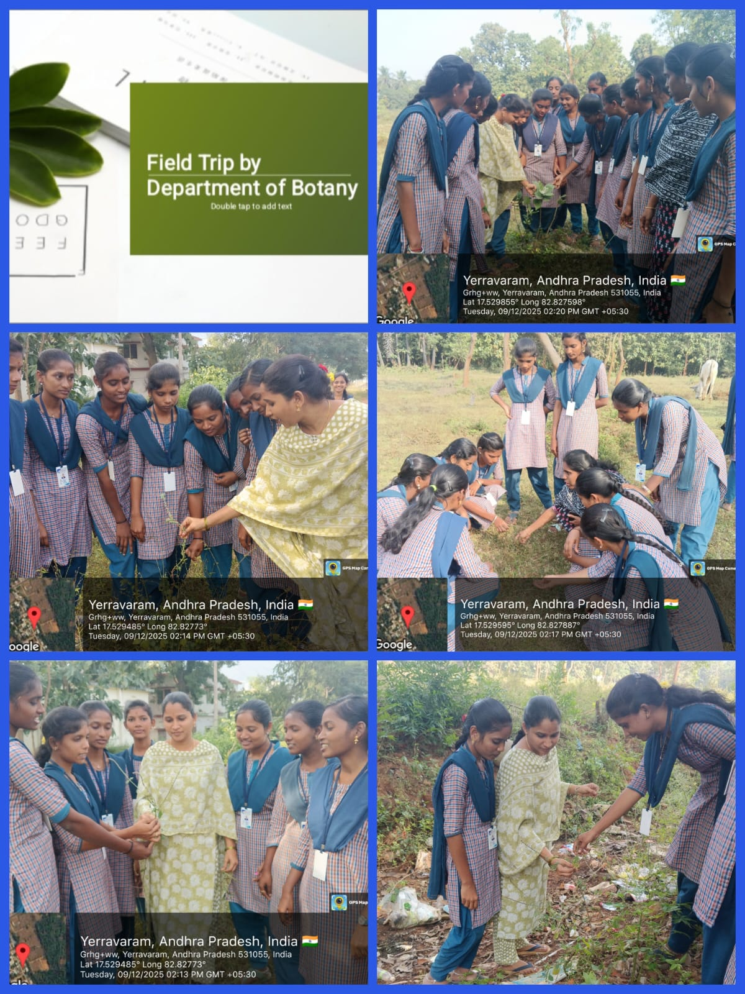

VILLAGE MEDICINAL PLANTS
Achyranthes aspera
The root paste or juice of A. aspera has been used externally in folk medicine to ease pain, reduce itching, manage rashes caused by insect bites, and provide relief in urticaria (hives)
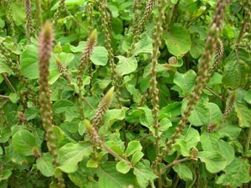
Calotropis gigantea
Calotropis is a plant. People use the bark and root bark for medicine. People use calotropis for conditions such as digestive disorders, toothache, cramps, joint pain, and many others, but there is no good scientific evidence to support these uses.
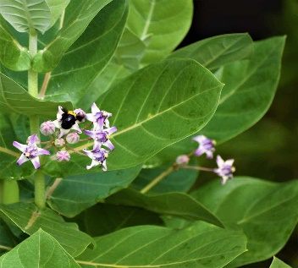
Aerva lanata
In traditional medicine the plant is used in cough, strangury (slow to be and painful discharge of urine), headache and urolithiasis.
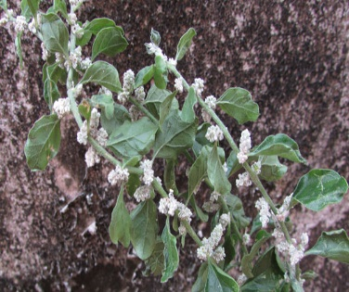

Phyllanthus niruri
Phyllanthus has been used in Ayurvedic medicine for over 2,000 years and has a wide number of traditional uses including internal use for jaundice, gonorrhea, frequent menstruation, and diabetes and topical use as a poultice for skin ulcers, sores, swelling, and itchiness.
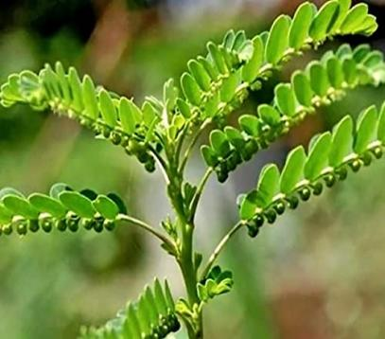

Euphorbia hirta
Euphorbia hirta is an herb. The parts of the plant that grow above the ground are used to make medicine. Euphorbia hirta is used for breathing disorders, dengue fever, digestive problems, severe diarrhea (dysentery), and many other conditions, but there is no good scientific evidence to support these uses.
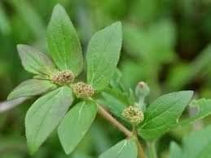


DEPARTMENT OF BOTANY
Educational tour to Dept of Botany,Andhra university on 13-03-2026
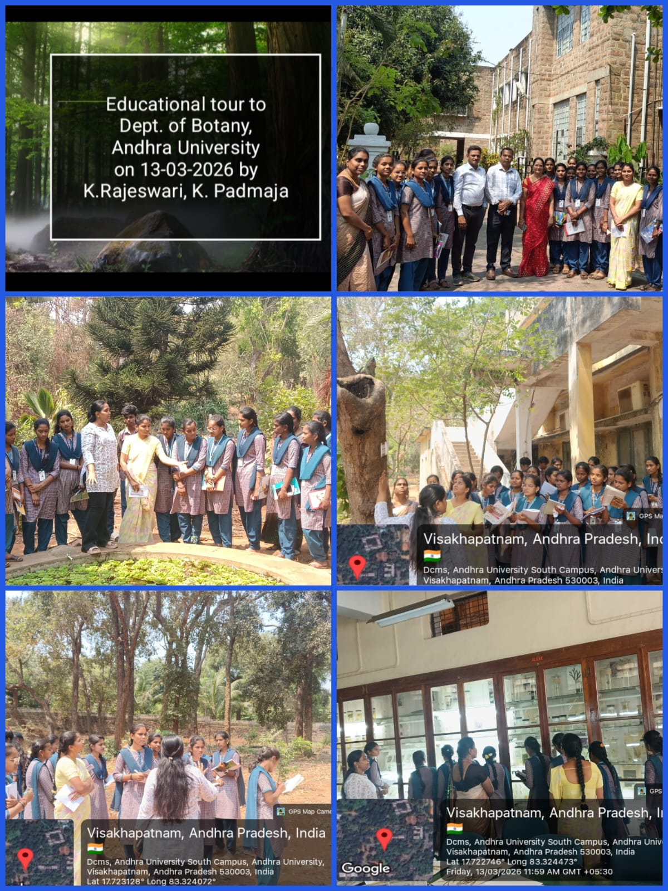
by K. Rajeswari, K. Padma

DEPARTMENT OF BOTANY
STUEDENTS PREPARED BY NURSERY BED AT ANDHRA UNIVERSITY, DEPT OF BOTANY
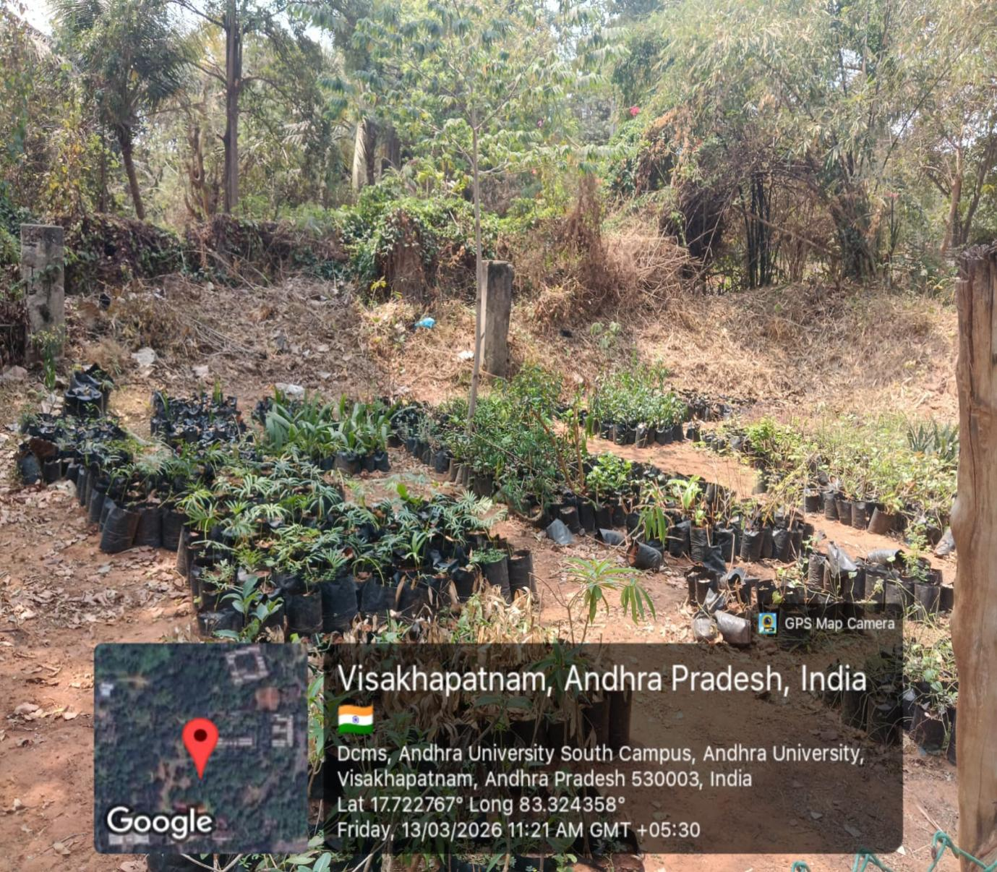
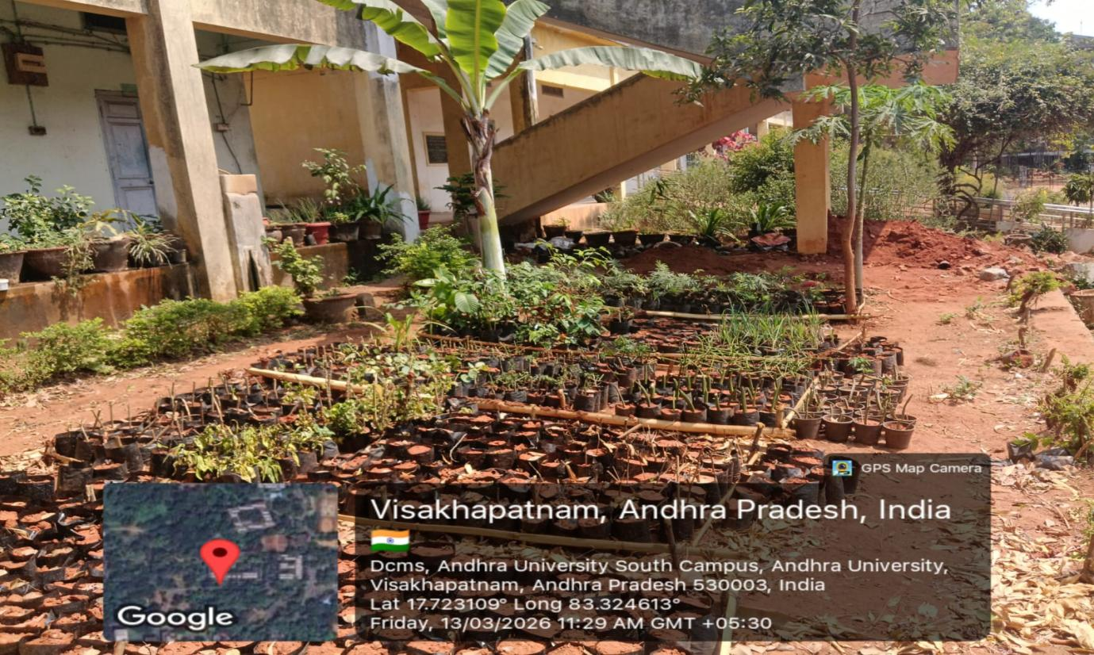

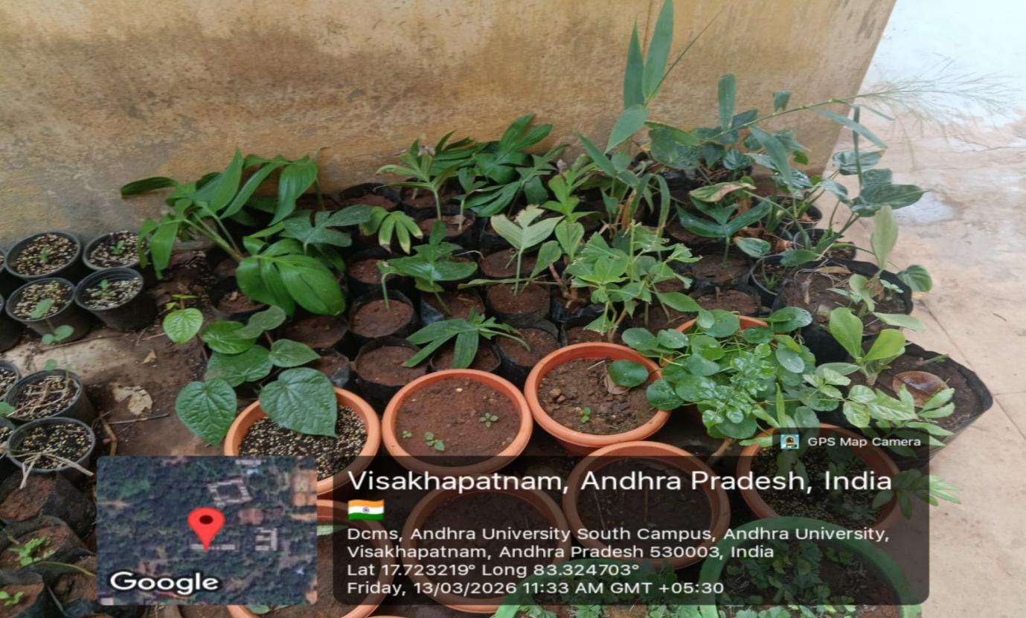

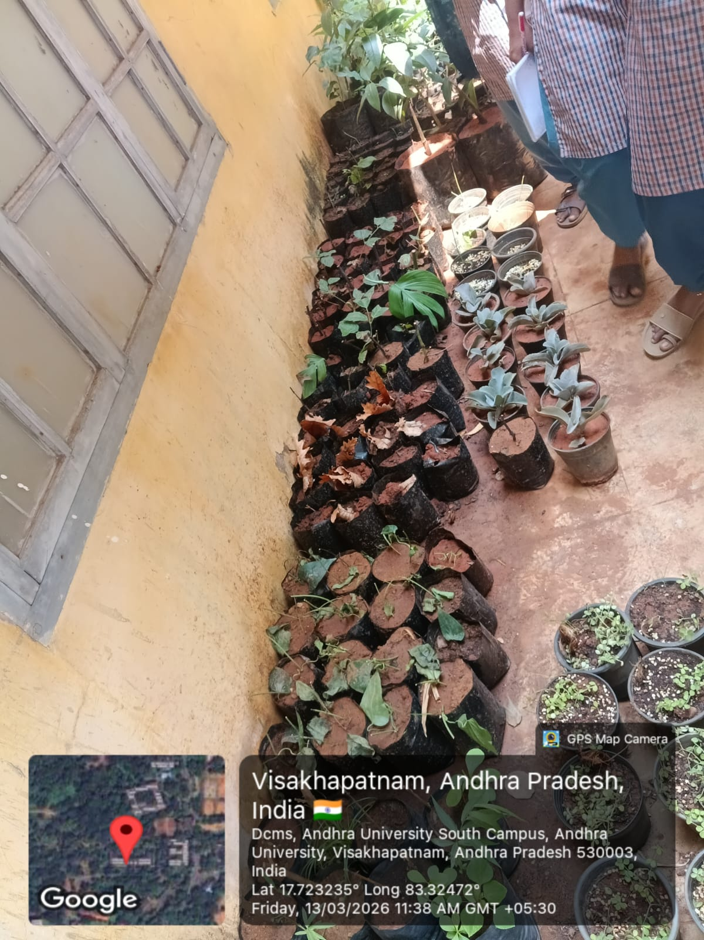

Report on Visit to Andhra University – Demonstration of Economic Plants and Nursery Plants to Students
A study visit was organized to Andhra University on 13-03-2026, Visakhapatnam, where the university staff demonstrated various economic plants and nursery plants to the students. The visit aimed to improve students’ knowledge about useful plants, their economic importance, and nursery management techniques.
During the visit, the staff of the Botany Department explained different economic plants that are valuable for food, medicine, timber, and other commercial purposes. Students observed plants such as
- Azadirachta indica (Neem)
- Cocos nucifera (Coconut)
- Mangifera indica (Mango)
- Ocimum tenuiflorum (Tulsi)
- Pterocarpus santalinus (Red sander)
- Santalum album (Sandal wood)
- Wrightia tinctoria (Indigo plant)
The staff explained their uses in medicine, agriculture, and daily life. Students learned how these plants contribute to the economy through products like fruits, oils, timber, and herbal medicines.
The university staff also introduced students to the plant nursery section. They explained the methods of raising healthy seedlings, soil preparation, watering techniques, and plant propagation methods such as seed sowing, cutting, and grafting. Different ornamental and medicinal plants were shown in nursery beds and pots.
Students actively participated by asking questions and observing plant varieties closely. The staff guided them on the importance of plant conservation, proper plant care, and the role of nurseries in agriculture and environmental protection.
The visit was very informative and useful for the students. It helped them understand the practical aspects of economic botany and nursery management. The students expressed their gratitude to the staff of Andhra University for sharing their knowledge and providing a valuable learning experience.

DEPARTMENT OF BOTANY
MUSEUM OF ANDHRA UNIVERSITY, DEPT OF BOTANY
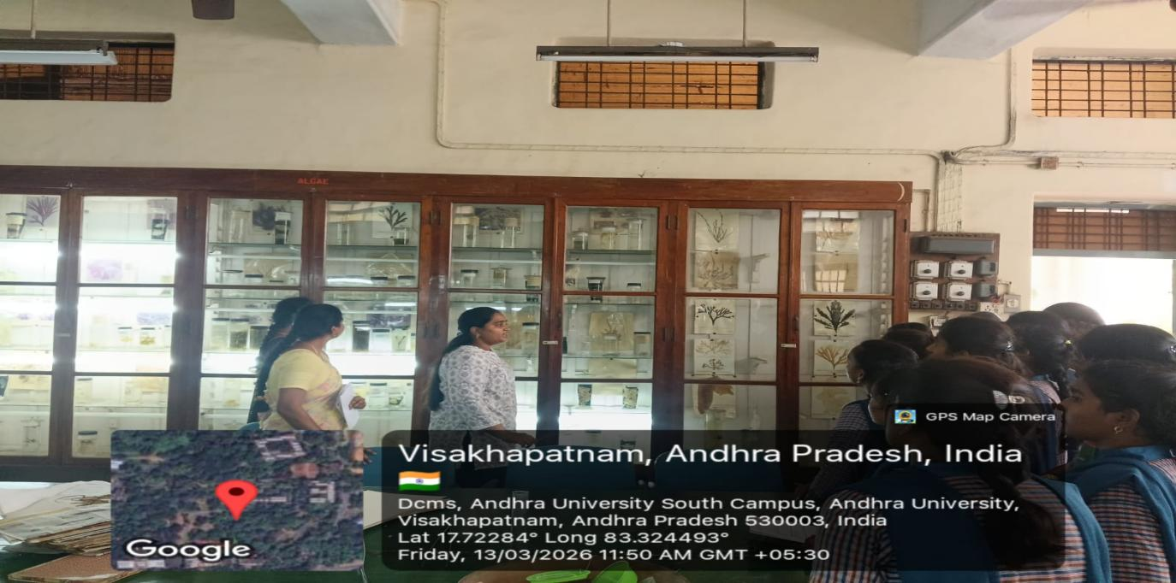
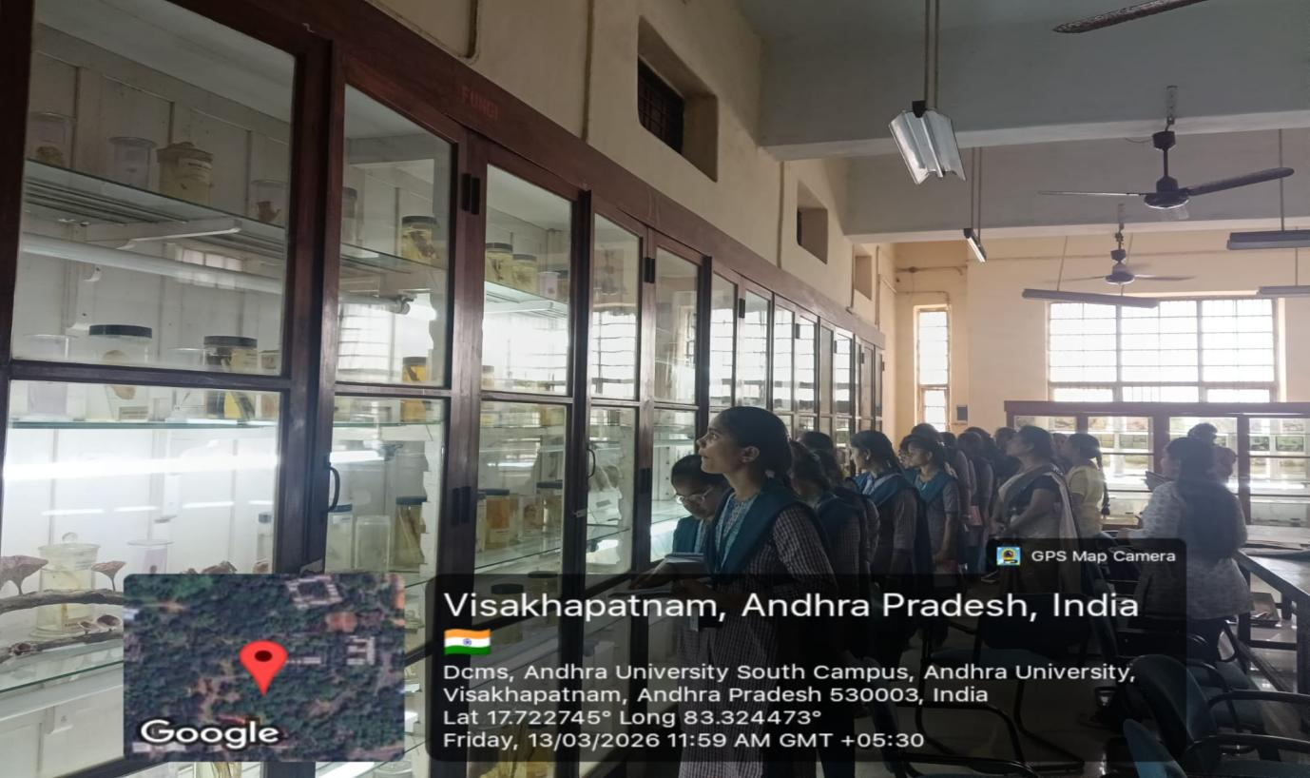

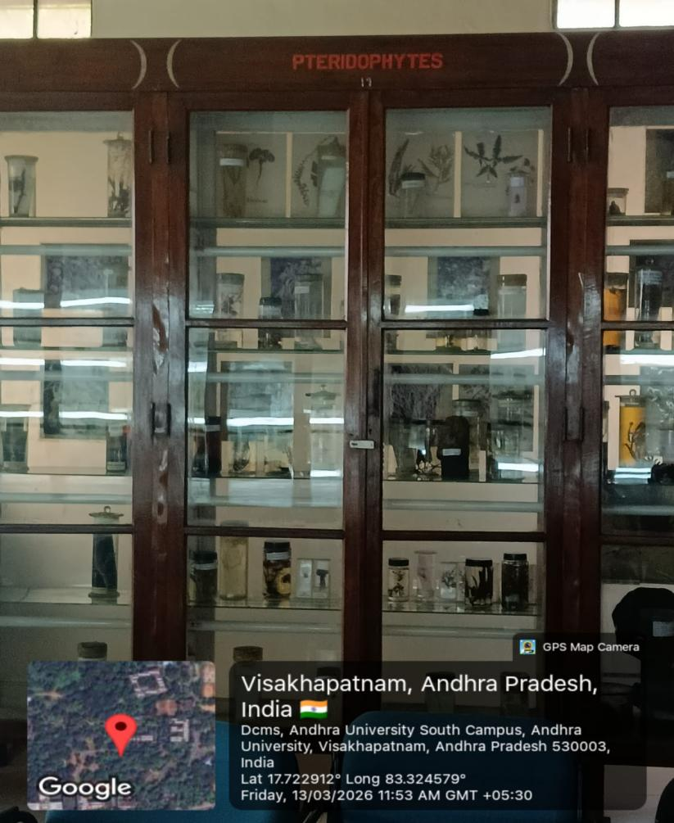
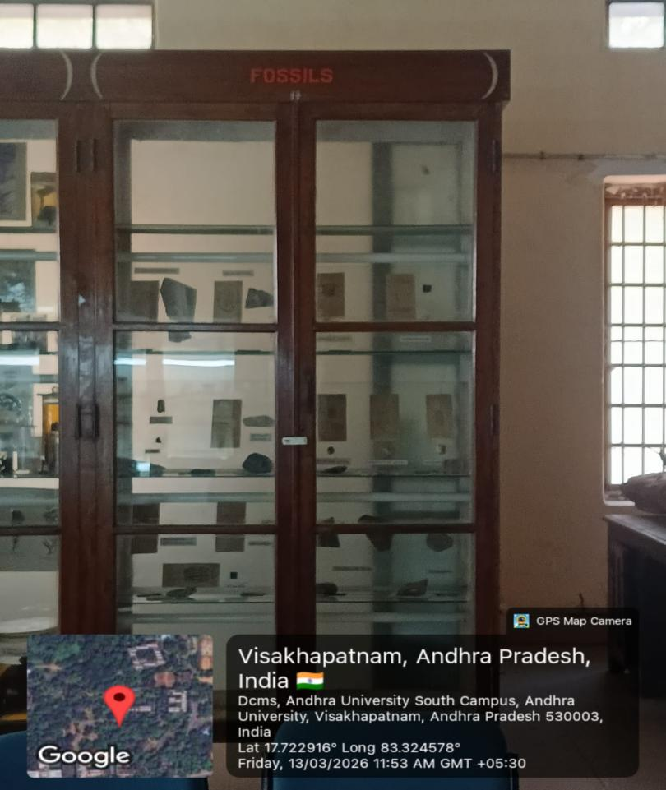

Report on Visit to Botany Museum at Andhra University on 13-03-2026
A study visit was organized for students to the Department of Botany museum at Andhra University, Visakhapatnam 13-03-2026. The purpose of the visit was to provide students with practical knowledge about different plant groups and preserved botanical specimens.
During the visit, the staff of the Botany Department explained the importance of the museum collections. The museum contained many preserved specimens related to various groups of plants and plant fossils. Students observed different fossils, which helped them understand the evolution and history of plants.
The staff also showed specimens of algae, which are simple aquatic plants that play an important role in oxygen production and aquatic ecosystems. Preserved samples of fungi were also displayed, and the staff explained their role in decomposition and their importance in medicine and food industries.
In addition, students were introduced to specimens of pteridophytes, which are vascular plants that reproduce through spores. The museum also displayed rare wood specimens, which helped students learn about different types of timber and their uses.
The staff further explained the characteristics of gymnosperms, which are seed-producing plants such as Cycas revoluta and Pinus roxburghii. These plants are important for understanding plant evolution.
Another important section of the museum displayed mangrove plants, which grow in coastal and saline environments. Students learned about the ecological importance of mangroves in protecting coastal areas and supporting biodiversity.
The visit was very informative and helped students gain practical exposure to different plant groups. The staff of Andhra University explained each specimen clearly and answered students’ questions patiently.

DEPARTMENT OF BOTANY
Seaweed Collection by visakha RK Beach on 13-03-2026
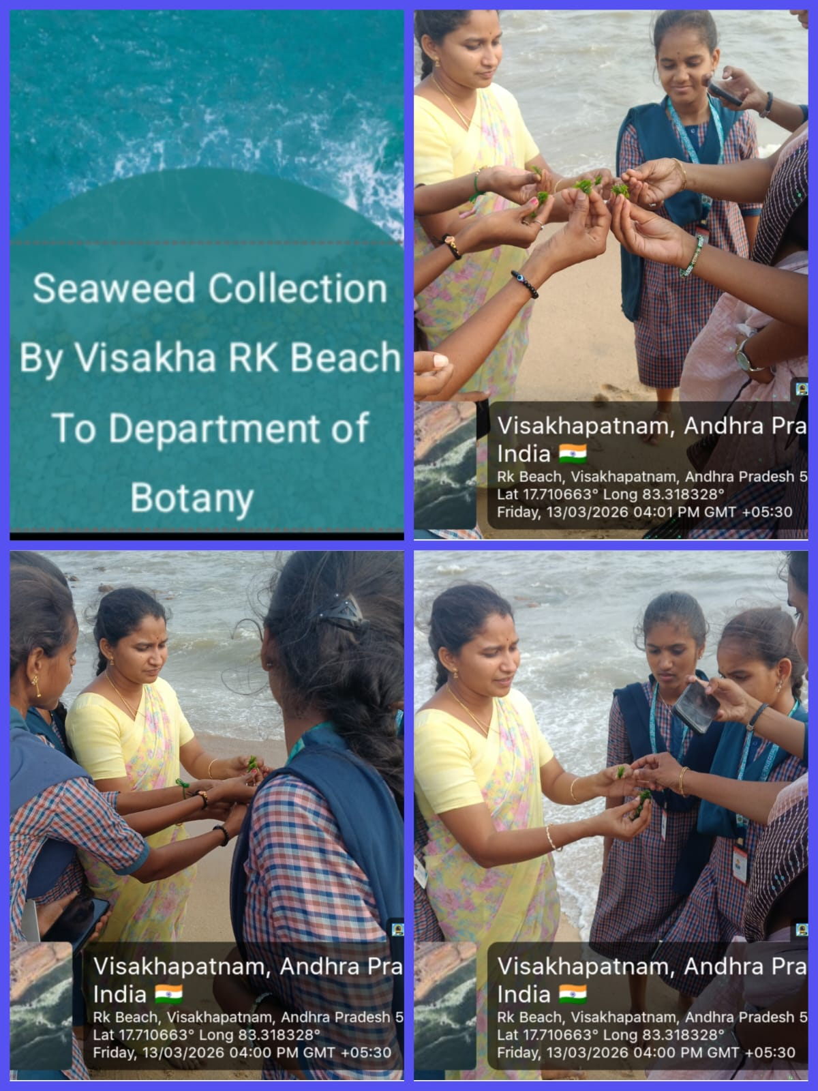

Report on Seaweed Collection at RK Beach, Visakhapatnam
A field visit was organized for students to collect and study seaweeds at Ramakrishna Beach, commonly known as RK Beach. The trip was conducted with the aim of giving students practical knowledge about marine algae and their ecological importance.
During the visit, students explored the coastal area and observed different types of seaweeds growing on rocks and in shallow water. Seaweeds are marine algae that play an important role in coastal ecosystems. The students collected various seaweed samples for study and identification.
The students observed different groups of seaweeds such as green algae, brown algae, and red algae. Some of the common seaweeds collected included Ulva lactuca, Sargassum, and Gracilaria. The teachers explained the characteristics, habitat, and economic importance of these marine plants.
The students were also informed about the uses of seaweeds in food, fertilizers, medicines, and industries. Seaweeds are important sources of products like agar and alginates, which are widely used in biotechnology and food processing.
During the collection process, students carefully gathered samples and preserved them for further study in the laboratory. They learned proper techniques for collecting and handling marine plant specimens.
The field visit was very interesting and educational. It helped students understand the diversity of marine algae and the importance of seaweeds in marine ecosystems.

